What is a Maven Repository?

In Maven terminology, a repository is a directory where all the project jars, library jar, plugins or any other project specific artifacts are stored and can be used by Maven easily.
Maven repository are of three types. The following illustration will give an idea regarding these three types.
- local
- central
- remote
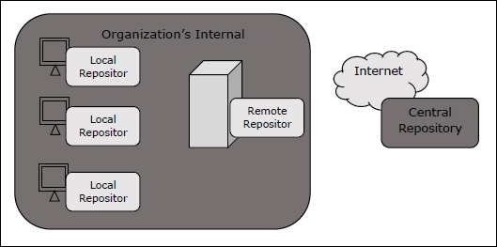

Local Repository
Maven local repository is a folder location on your machine. It gets created when you run any maven command for the first time.
Maven local repository keeps your project's all dependencies (library jars, plugin jars etc.). When you run a Maven build, then Maven automatically downloads all the dependency jars into the local repository. It helps to avoid references to dependencies stored on remote machine every time a project is build.
Maven local repository by default get created by Maven in %USER_HOME% directory. To override the default location, mention another path in Maven settings.xml file available at %M2_HOME%\conf directory.
<settings xmlns = "http://maven.apache.org/SETTINGS/1.0.0"
xmlns:xsi = "http://www.w3.org/2001/XMLSchema-instance"
xsi:schemaLocation = "http://maven.apache.org/SETTINGS/1.0.0
http://maven.apache.org/xsd/settings-1.0.0.xsd">
<localRepository>C:/MyLocalRepository</localRepository>
</settings>
When you run Maven command, Maven will download dependencies to your custom path.

Central Repository
Maven central repository is repository provided by Maven community. It contains a large number of commonly used libraries.
When Maven does not find any dependency in local repository, it starts searching in central repository using following URL − https://repo1.maven.org/maven2/
Key concepts of Central repository are as follows −
- This repository is managed by Maven community.
- It is not required to be configured.
- It requires internet access to be searched.
To browse the content of central maven repository, maven community has provided a URL − https://search.maven.org/#browse. Using this library, a developer can search all the available libraries in central repository.

Remote Repository
Sometimes, Maven does not find a mentioned dependency in central repository as well. It then stops the build process and output error message to console. To prevent such situation, Maven provides concept of Remote Repository, which is developer's own custom repository containing required libraries or other project jars.
For example, using below mentioned POM.xml, Maven will download dependency (not available in central repository) from Remote Repositories mentioned in the same pom.xml.
<project xmlns = "http://maven.apache.org/POM/4.0.0"
xmlns:xsi = "http://www.w3.org/2001/XMLSchema-instance"
xsi:schemaLocation = "http://maven.apache.org/POM/4.0.0
http://maven.apache.org/xsd/maven-4.0.0.xsd">
<modelVersion>4.0.0</modelVersion>
<groupId>com.companyname.projectgroup</groupId>
<artifactId>project</artifactId>
<version>1.0</version>
<dependencies>
<dependency>
<groupId>com.companyname.common-lib</groupId>
<artifactId>common-lib</artifactId>
<version>1.0.0</version>
</dependency>
<dependencies>
<repositories>
<repository>
<id>companyname.lib1</id>
<url>http://download.companyname.org/maven2/lib1</url>
</repository>
<repository>
<id>companyname.lib2</id>
<url>http://download.companyname.org/maven2/lib2</url>
</repository>
</repositories>
</project>

Maven Dependency Search Sequence
When we execute Maven build commands, Maven starts looking for dependency libraries in the following sequence −
- Step 1 − Search dependency in local repository, if not found, move to step 2 else perform the further processing.
- Step 2 − Search dependency in central repository, if not found and remote repository/repositories is/are mentioned then move to step 4. Else it is downloaded to local repository for future reference.
- Step 3 − If a remote repository has not been mentioned, Maven simply stops the processing and throws error (Unable to find dependency).
- Step 4 − Search dependency in remote repository or repositories, if found then it is downloaded to local repository for future reference. Otherwise, Maven stops processing and throws error (Unable to find dependency).

